Experiment-1

**AIM**: Identification and Installation of python environment towards the machine learning, installing python modules/Packages Import scikitlearn, keras and tensorflows etc.

**DESCRIPTION:**

Python is a high-level, general-purpose programming language. Its design philosophy emphasizes code readability with the use of significant indentation.

Python is dynamically typed and garbage collected. It supports multiple programming paradigms, including structured (particularly procedural), object-oriented and functional programming. It is often described as a "batteries included" language due to its comprehensive standard library.

scikit-learn (formerly scikits.learn and also known as sklearn) is a free software machine learning library for the Python programming language.It features various classification, regression and clustering algorithms including support-vector machines, random forests, gradient boosting, k-means and DBSCAN, and is designed to interoperate with the Python numerical and scientific libraries NumPy and SciPy.

Keras is an open-source software library that provides a Python interface for artificial neural networks. Keras acts as an interface for the TensorFlow library.

TensorFlow is a free and open-source software library for machine learning and artificial intelligence. It can be used across a range of tasks but has a particular focus on training and inference of deep neural networks.

**DOWNLOADING PYTHON**

**Step 1:** Go to<https://www.python.org/>

The following page would be visible

**Step 2:** Click the **Download Python 3.9.6** button. The following pop-up window titled **Opening python-3.96-amd64.exe** will appear.

Click the **Save File** button.

The file named **python-3.9.6-amd64.exe** should start downloading into your standard download folder.

**Step 3:** Move this file to a more permanent location, so that you can install Python (and reinstall it easily later, if necessary).

**Step 4:** Feel free to explore this webpage further; if you want to just continue the installation, you can terminate the tab browsing this webpage.

**Step 5:** Start the **Installing** instructions directly below.

**Installing**

1. Double-click the icon labeling the file **python-3.9.6-amd64.exe**.

A **Python 3.9.6 (64-bit) Setup** pop-up window will appear.

Ensure that **both** the **Install launcher for all users (recommended)** and the **Add Python 3.9 to PATH** checkboxes at the bottom are checked: typically only first is checked by default.

If the Python Installer finds an earlier version of Python installed on your computer, the **Install Now** message may instead appear as **Upgrade Now** (and the checkboxes will not appear).

2. Highlight the **Install Now** (or **Upgrade Now**) message, and then click it.

When run, a **User Account Control** pop-up window may appear on your screen. I could not capture its image, but it asks, **Do you want to allow this app to make changes to your device**.

3. Click the **Yes** button.

A new **Python 3.9.6 (64-bit) Setup** pop-up window will appear with a **Setup Progress** message and a progress bar.

During installation, it will show the various components it is installing and move the progress bar towards completion. Soon, a new **Python 3.9.6 (64-bit) Setup** pop-up window will appear with a **Setup was successfuly** message.

4. Click the **Close** button.

Python should now be installed.

**INSTALLING SCIKIT-LEARN**

1. Go to the command prompt

2. Type pip install scikit-learn

3. The package will be downloaded

**INSTALLING KERAS**

1. Go to the command prompt

2. Install numpy, pandas, matplotlib, scikit learn before installing keras

3. Type pip install keras

4. The package will be downloaded

**INSTALLING TENSORFLOW**

1. Go to the command prompt

2. Type pip install tensorflow

3. The package will be downloaded

**IMPORTING SCIKITLEARN**

Command – import sklearn

**IMPORTING KERAS**

Command – import keras

**IMPORTING TENSORFLOW**

Command – import tensorflow

**CONCLUSION:**

Successfully installed modules/packages needed for machine learning.

Experiment-2

**AIM:** Build linear regression model using gradient descent, least squares, polynomial, LASSO and RIDGE approaches also compare all the algorithms and draw a table for all the metrics.

**DESCRIPTION:**

Linear regression algorithm shows a linear relationship between a dependent (y) and one or more independent (y) variables, hence called as linear regression. Since linear regression shows the linear relationship, which means it finds how the value of the dependent variable is changing according to the value of the independent variable.

The linear regression model provides a sloped straight line representing the relationship between the variables. Consider the below image:

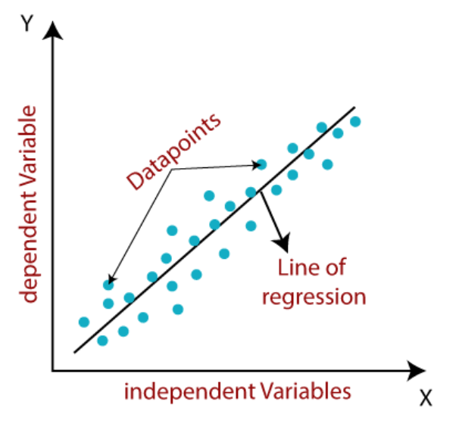

**Gradient Descent:**

* Gradient descent is used to minimize the MSE by calculating the gradient of the cost function.
* A regression model uses gradient descent to update the coefficients of the line by reducing the cost function.
* It is done by a random selection of values of coefficient and then iteratively update the values to reach the minimum cost function.

**Least Square Method :**

The least squares method is a common technique used in machine learning to fit a linear regression model to a given dataset. The goal is to find the line that best fits the data by minimizing the sum of the squared differences between the predicted values and the actual values.

The basic idea is to find the slope and intercept of the line that minimize the sum of the squared errors (the difference between the predicted and actual values). This can be done using a mathematical formula, which involves taking the derivative of the sum of squared errors with respect to the parameters (slope and intercept) and setting them to zero.

Once the optimal values of the parameters have been found, they can be used to make predictions for new input values.

The least squares method assumes that the errors in the data are normally distributed and that the variance of the errors is constant across all values of the input variable. It is also sensitive to outliers, which can significantly affect the fitted line.

**Lasso Method:**

The Lasso method is a technique used in linear regression to reduce the complexity of the model and prevent overfitting. It is a type of regularization that adds a penalty term to the cost function of the linear regression model, which helps in shrinking the coefficient values of some features to zero. This, in turn, helps in feature selection and simplifying the model.

The Lasso method involves adding a penalty term proportional to the absolute value of the coefficients to the cost function. This penalty term forces the model to shrink the coefficients towards zero and select only the most relevant features. The amount of shrinkage is controlled by the regularization parameter, which can be tuned using cross-validation techniques.

The Lasso method is particularly useful when dealing with high-dimensional data, where the number of features is much larger than the number of observations. It has been widely used in applications such as gene expression analysis, image processing, and natural language processing, among others.

**Ridge regression:**

Ridge regression is a regularization technique that is commonly used in linear regression to prevent overfitting. It is also known as L2 regularization because it adds a penalty term to the sum of squared residuals that is proportional to the square of the magnitude of the coefficients.

The Ridge regression method works by adding a penalty term to the cost function, which shrinks the coefficients towards zero. The amount of shrinkage is controlled by a hyperparameter called lambda (λ). Higher values of λ result in more shrinkage and lower values result in less shrinkage. The goal is to find the optimal value of λ that minimizes the sum of squared residuals while also preventing overfitting.

The ridge regression algorithm is similar to the standard linear regression algorithm, but with an additional penalty term added to the cost function. The resulting optimization problem can be solved using various methods, such as gradient descent or closed-form solutions.

Ridge regression can be used when there are many features in the dataset, or when the features are highly correlated with each other. It helps to reduce the variance in the model and improve its generalization performance on unseen data.

**CODE & OUTPUT:**

**Importing the libraries**

import numpy as np

import matplotlib.pyplot as plt

import pandas as pd

Importing the dataset

dataset = pd.read_csv('Salary_Data.csv')

X = dataset.iloc[:, :-1].values

y = dataset.iloc[:, -1].values

**Splitting the dataset into the Training set and Test set**

from sklearn.model_selection import train_test_split

X_train, X_test, y_train, y_test = train_test_split(X, y, test_size = 1/3, random_state = 0)

**Training the Simple Linear Regression model on the Training set**

from sklearn.linear_model import LinearRegression

regressor = LinearRegression()

regressor.fit(X_train, y_train)

#**Predicting the Test set results**

y_pred = regressor.predict(X_test)

**Visualising the Training set results**

plt.scatter(X_train, y_train, color = 'red')

plt.plot(X_train, regressor.predict(X_train), color = 'blue')

plt.title('Salary vs Experience (Training set)')

plt.xlabel('Years of Experience')

plt.ylabel('Salary')

plt.show()

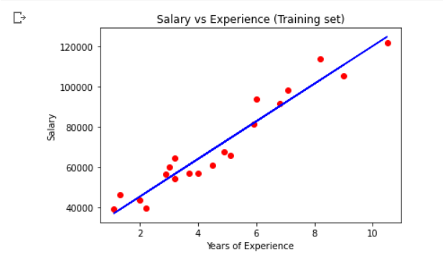

**Visualising the Test set results**

plt.scatter(X_test, y_test, color = 'red')

plt.plot(X_train, regressor.predict(X_train), color = 'blue')

plt.title('Salary vs Experience (Test set)')

plt.xlabel('Years of Experience')

plt.ylabel('Salary')

plt.show()

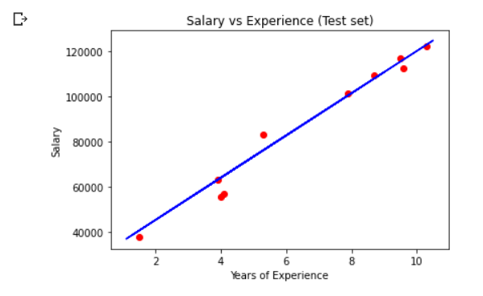

**Implementing the model**

#importing required libraries

import numpy as np

import pandas as pd

import matplotlib.pyplot as plt

#rcParams => You can dynamically change the default rc (runtime configuration)

#settings in a python script or interactively from the python shell.

#All rc settings are stored in a dictionary-like variable called matplotlib.rcParams,

#which is global to the matplotlib package. See matplotlib.rcParams for a full list of configurable rcParams.

plt.rcParams['figure.figsize']=(12.0,9.0)

#preprocessing the input data

data=pd.read_csv('data.csv')

#The iloc() function in python is defined in the Pandas module

#that helps us to select a specific row or column from the data set.

# Using the iloc method in python, we can easily retrieve any particular

#value from a row or column by using index values.

X=data.iloc[:,0]

Y=data.iloc[:,1]

plt.scatter(X,Y)

plt.show()

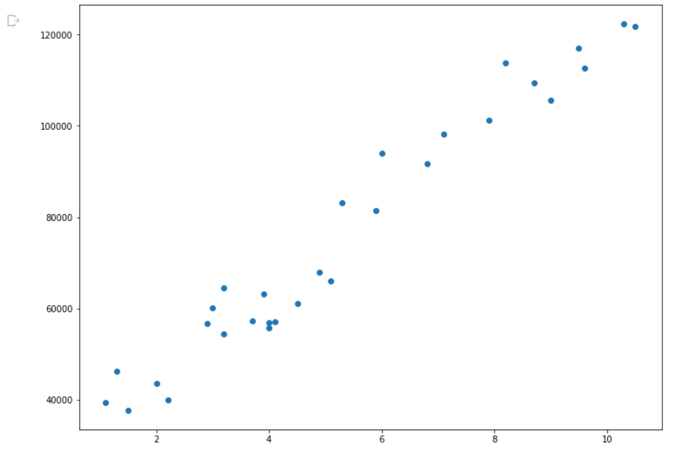

**Linear Regression using Least Squares Method**

#building the model

X_mean = np.mean(X)

Y_mean = np.mean(Y)

num=0

den=0

for i in range(len(X)):

  num+=(X[i]-X_mean)*(Y[i]-Y_mean)

  den+=(X[i]-X_mean)**2

m=num/den

c=Y_mean - m*X_mean

print(m,c)

#Making predictions

Y_pred = m*X+c

plt.scatter(X,Y)

plt.title('Linear Regression using Least Square')

plt.plot([min(X),max(X)],[min(Y_pred),max(Y_pred)],color="red")

plt.show()

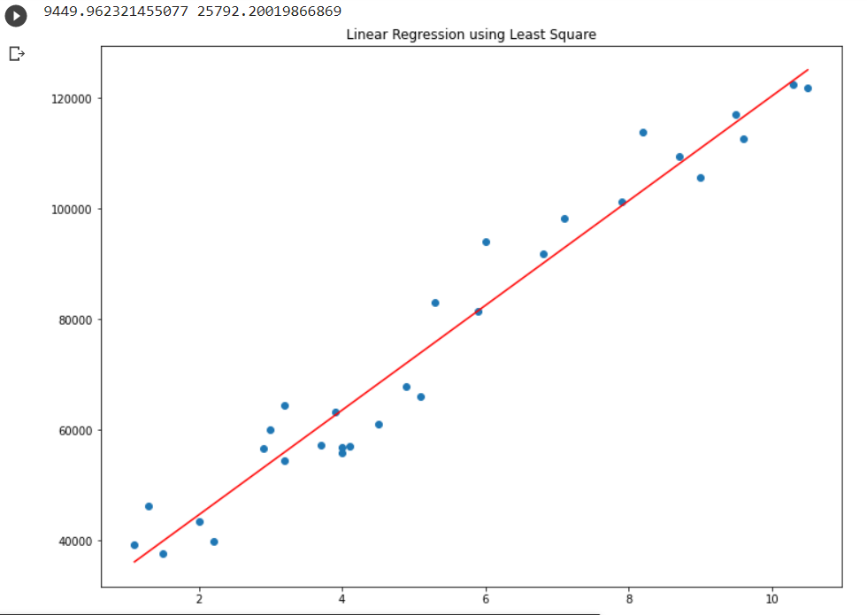

**Linear Regression using Gradient Descent Method**

#building the model

m=0 #slope

c=0 #intercept

L=0.0001 #learning rate

epochs=1000 #the number iterations performed gradient descent

n=float(len(X)) # no.of elements in X

#performing gradient descent

for i in range(epochs):

  Y_pred=m*X+c #The current predicted value  of Y

  D_m=(-2/n)* sum(X*(Y-Y_pred)) #  Derivative w.r.t m

  D_c=(-2/n)* sum(Y-Y_pred) #Derivative w.r.t c

  m=m-L * D_m # update m

  c=c-L * D_c # update  c

print(m,c)

#Making predictions

Y_pred=m*X+c

plt.scatter(X,Y)

plt.title('Linear Regression using Gradient Descent')

plt.plot([min(X),max(X)],[min(Y_pred),max(Y_pred)],color="red")

plt.show()

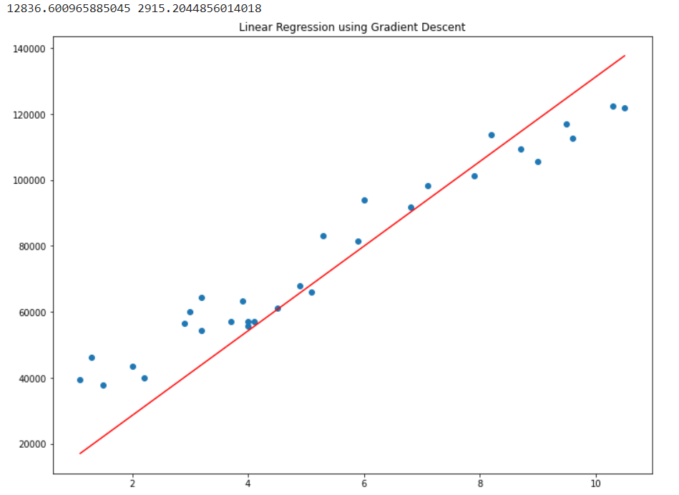

**Ridge Regression**

# import necessary libraries

import numpy as np

import pandas as pd

import matplotlib.pyplot as plt

dataset=pd.read_csv('Salary_Data.csv')

x=dataset.iloc[:,:-1]

y=dataset.iloc[:,-1]

# split the data into training and testing sets

from sklearn.model_selection import train_test_split

x_train, x_test, y_train, y_test = train_test_split(x,y,test_size=0.25,random_state=0)

# standardize the features

from sklearn.preprocessing import StandardScaler

scaler = StandardScaler()

x_train = scaler.fit_transform(x_train)

x_test = scaler.transform(x_test)

# create a ridge regression object

from sklearn.linear_model import Ridge

las=Ridge(alpha=1.0)

# fit the model on the training data

las.fit(x_train,y_train)

# predict the target values for the test data

y_pred=las.predict(x_test)

**Visualizing training data**

las=Ridge(alpha=1.0)

las.fit(x_train,y_train)

plt.scatter(x_train,y_train,color="red")

plt.plot(x_train,las.predict(x_train),color="blue")

las=Ridge(alpha=10)

las.fit(x_train,y_train)

plt.scatter(x_train,y_train,color="red")

plt.plot(x_train,las.predict(x_train),color="green")

las=Ridge(alpha=100)

las.fit(x_train,y_train)

plt.scatter(x_train,y_train,color="red")

plt.plot(x_train,las.predict(x_train),color="yellow")

las=Ridge(alpha=300)

las.fit(x_train,y_train)

plt.scatter(x_train,y_train,color="red")

plt.plot(x_train,las.predict(x_train),color="orange")

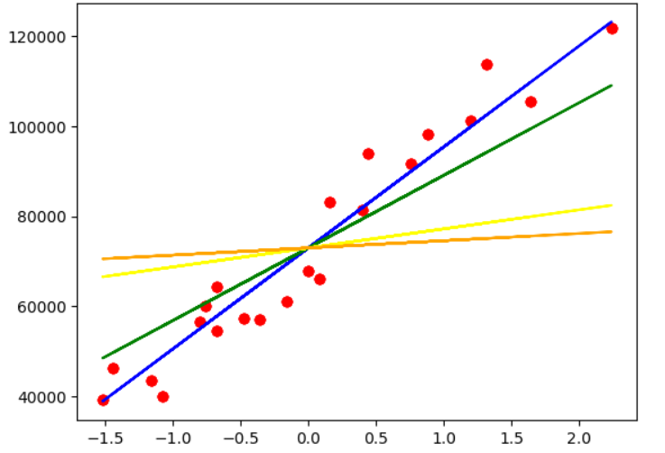

**Visualizing testing data**

las=Ridge(alpha=1.0)

las.fit(x_train,y_train)

plt.scatter(x_test,y_test,color="red")

plt.plot(x_test,las.predict(x_test),color="blue")

las=Ridge(alpha=10)

las.fit(x_train,y_train)

plt.scatter(x_test,y_test,color="red")

plt.plot(x_test,las.predict(x_test),color="green")

las=Ridge(alpha=100)

las.fit(x_train,y_train)

plt.scatter(x_test,y_test,color="red")

plt.plot(x_test,las.predict(x_test),color="yellow")

las=Ridge(alpha=300)

las.fit(x_train,y_train)

plt.scatter(x_test,y_test,color="red")

plt.plot(x_test,las.predict(x_test),color="orange")

**Lasso Regression**

# import necessary libraries

import numpy as np

import pandas as pd

import matplotlib.pyplot as plt

dataset=pd.read_csv('Salary_Data.csv')

x=dataset.iloc[:,:-1]

y=dataset.iloc[:,-1]

# split the data into training and testing sets

from sklearn.model_selection import train_test_split

x_train, x_test, y_train, y_test = train_test_split(x,y,test_size=0.25,random_state=0)

# standardize the features

from sklearn.preprocessing import StandardScaler

scaler = StandardScaler()

x_train = scaler.fit_transform(x_train)

x_test = scaler.transform(x_test)

# create a Lasso regression object

from sklearn.linear_model import Lasso

las=Lasso(alpha=0.1)

# fit the model on the training data

las.fit(x_train,y_train)

# predict the target values for the test data

y_pred=las.predict(x_test)

# print the R-squared score of the model

print("R-squared score: {:.2f}".format(las.score(x_test, y_test)))



**Visualizing Training data**

plt.scatter(x_train,y_train,color="red")

plt.plot(x_train,las.predict(x_train),color="blue")

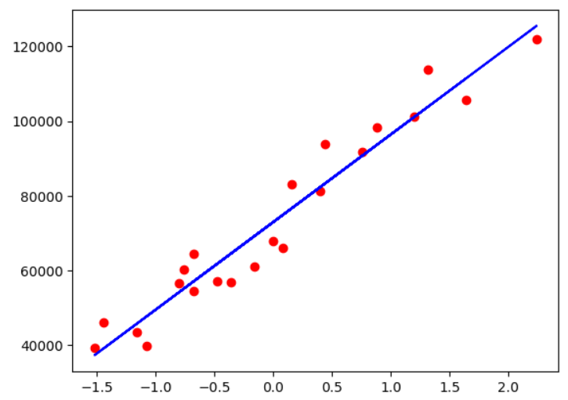

**Visualizing Testing data**

plt.scatter(x_test,y_test,color="red")

plt.plot(x_test,las.predict(x_test),color="blue")

**CONCLUSION:**

1.Illustrated linear regression model using gradient descent, least squares, polynomial, LASSO and RIDGE approaches.

2.Visualised the regression lines obtained.

Experiment-3

**AIM:** To implement the Decision Tree algorithm for a given data set and visualize the output.

**DESCRIPTION:**

* Decision Tree is a Supervised learning technique that can be used for both classification and Regression problems, but mostly it is preferred for solving Classification problems. It is a tree-structured classifier, where internal nodes represent the features of a dataset, branches represent the decision rules and each leaf node represents the outcome.
* In a Decision tree, there are two nodes, which are the Decision Node and Leaf Node. Decision nodes are used to make any decision and have multiple branches, whereas Leaf nodes are the output of those decisions and do not contain any further branches.
* The decisions or the test are performed on the basis of features of the given dataset.
* It is a graphical representation for getting all the possible solutions to a problem/decision based on given conditions.
* It is called a decision tree because, similar to a tree, it starts with the root node, which expands on further branches and constructs a tree-like structure.
* In order to build a tree, we use the CART algorithm, which stands for Classification and Regression Tree algorithm.
* A decision tree simply asks a question, and based on the answer (Yes/No), it further split the tree into subtrees.

**CODE & OUTPUT:**

**Implementing the model**

#importing required libraries

import numpy as np

import matplotlib.pyplot as plt

import pandas as pd

**Importing the dataset**

dataset = pd.read_csv('Social_Network_Ads.csv')

X = dataset.iloc[:, :-1].values

y = dataset.iloc[:, -1].values

**Splitting the dataset into training set and test set**

from sklearn.model_selection import train_test_split

X_train, X_test, y_train, y_test = train_test_split(X, y, test_size = 0.25, random_state = 0)

print(X_train)

print(y_train)

print(X_test)

print(y_test)

**Feature Scaling**

from sklearn.preprocessing import StandardScaler

sc = StandardScaler()

X_train = sc.fit_transform(X_train)

X_test = sc.transform(X_test)

print(X_train)

print(X_test)

**Training the decision tree classification model on the training set**

from sklearn.tree import DecisionTreeClassifier

classifier = DecisionTreeClassifier(criterion = 'entropy', random_state = 0)

classifier.fit(X_train, y_train)

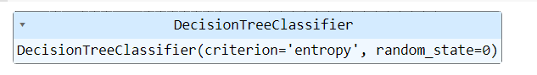

**Predicting a new result**

print(classifier.predict(sc.transform([[30,87000]])))



**Predicting the Test set results**

y_pred = classifier.predict(X_test)

print(np.concatenate((y_pred.reshape(len(y_pred),1), y_test.reshape(len(y_test),1)),1))

**Making the confusion matrix**

from sklearn.metrics import confusion_matrix, accuracy_score

cm = confusion_matrix(y_test, y_pred)

print(cm)

accuracy_score(y_test, y_pred)

# Finding precision and recall

from sklearn.metrics import precision_score, recall_score

c=precision_score(y_test, y_pred)

d=recall_score(y_test, y_pred)

print(c,end="\n")

print(d)

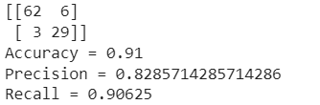

from sklearn.tree import plot_tree

import matplotlib.pyplot as plt

# Visualizing the decision tree for training set

plt.figure(figsize=(50,50))

plot_tree(classifier, filled=True, feature_names=['Age', 'Estimated Salary'], class_names=['Not Purchased', 'Purchased'])

plt.show()

**CONCLUSION:**

1.Illustrated Decision Tree algorithm and visualised the output.

2.The accuracy, precision and recall were found to be 0.91,0.83 and 0.9 respectively.

Experiment-4

**AIM:** To implement the K-Nearest Neighbours algorithm for a given data set and visualize the output.

**DESCRIPTION:**

* K-Nearest Neighbour is one of the simplest Machine Learning algorithms based on Supervised Learning technique.
* K-NN algorithm assumes the similarity between the new case/data and available cases and put the new case into the category that is most similar to the available categories.
* K-NN algorithm stores all the available data and classifies a new data point based on the similarity. This means when new data appears then it can be easily classified into a well suite category by using K- NN algorithm.
* K-NN algorithm can be used for Regression as well as for Classification but mostly it is used for the Classification problems.
* K-NN is a non-parametric algorithm, which means it does not make any assumption on underlying data.
* It is also called a lazy learner algorithm because it does not learn from the training set immediately instead it stores the dataset and at the time of classification, it performs an action on the dataset.
* KNN algorithm at the training phase just stores the dataset and when it gets new data, then it classifies that data into a category that is much similar to the new data.

**CODE & OUTPUT:**

**Importing the libraries**

import numpy as np

import matplotlib.pyplot as plt

import pandas as pd

**Importing the dataset**

dataset = pd.read_csv('Social_Network_Ads.csv')

X = dataset.iloc[:, :-1].values

y = dataset.iloc[:, -1].values

**Splitting the dataset into the Training set and Test set**

from sklearn.model_selection import train_test_split

X_train, X_test, y_train, y_test = train_test_split(X, y, test_size = 0.25, random_state = 0)

print(X_train)

print(y_train)

print(X_test)

print(y_test)

**Feature Scaling**

from sklearn.preprocessing import StandardScaler

sc = StandardScaler()

X_train = sc.fit_transform(X_train)

X_test = sc.transform(X_test)

print(X_train)

print(X_test)

**Training the K-NN model on the Training set**

from sklearn.neighbors import KNeighborsClassifier

classifier = KNeighborsClassifier(n_neighbors = 5, metric = 'minkowski', p = 2)

classifier.fit(X_train, y_train)

print(classifier.predict(sc.transform([[30,87000]])))

**Predicting the Test set results**

y_pred = classifier.predict(X_test)

print(np.concatenate((y_pred.reshape(len(y_pred),1), y_test.reshape(len(y_test),1)),1))

**Making the Confusion Matrix**

from sklearn.metrics import confusion_matrix, accuracy_score

cm = confusion_matrix(y_test, y_pred)

print(cm)

accuracy_score(y_test, y_pred)

# Finding precision and recall

from sklearn.metrics import precision_score, recall_score

c=precision_score(y_test, y_pred)

d=recall_score(y_test, y_pred)

print(c,end="\n")

print(d)

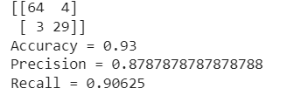

**CONCLUSION:**

1.Illustrated KNN algorithm and visualised the output.

2.The accuracy, precision and recall were found to be 0.93,0.88 and 0.91 respectively.

Experiment-5

**AIM:** To implement logistic regression algorithm for a given data set and visualize the output.

**DESCRIPTION:**

* Logistic regression is one of the most popular Machine Learning algorithms, which comes under the Supervised Learning technique. It is used for predicting the categorical dependent variable using a given set of independent variables.
* Logistic regression predicts the output of a categorical dependent variable. Therefore the outcome must be a categorical or discrete value. It can be either Yes or No, 0 or 1, true or False, etc. but instead of giving the exact value as 0 and 1, it gives the probabilistic values which lie between 0 and 1.
* Logistic Regression is much similar to the Linear Regression except that how they are used. Linear Regression is used for solving Regression problems, whereas Logistic regression is used for solving the classification problems.
* In Logistic regression, instead of fitting a regression line, we fit an "S" shaped logistic function, which predicts two maximum values (0 or 1).
* The curve from the logistic function indicates the likelihood of something such as whether the cells are cancerous or not, a mouse is obese or not based on its weight, etc.
* Logistic Regression is a significant machine learning algorithm because it has the ability to provide probabilities and classify new data using continuous and discrete datasets.
* Logistic Regression can be used to classify the observations using different types of data and can easily determine the most effective variables used for the classification. The below image is showing the logistic function:

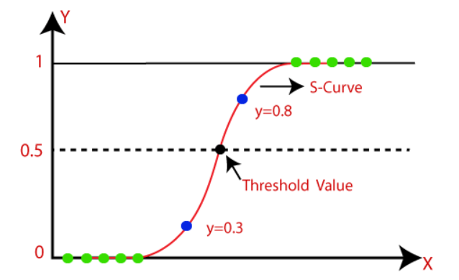

**CODE & OUTPUT:**

**Importing the libraries**

import numpy as np

import matplotlib.pyplot as plt

import pandas as pd

**Importing the dataset**

dataset = pd.read_csv('Social_Network_Ads.csv')

X = dataset.iloc[:, :-1].values

y = dataset.iloc[:, -1].values

**Splitting the dataset into the Training set and Test set**

from sklearn.model_selection import train_test_split

X_train, X_test, y_train, y_test = train_test_split(X, y, test_size = 0.25, random_state = 0)

print(X_train)

print(y_train)

print(X_test)

print(y_test)

**Feature Scaling**

from sklearn.preprocessing import StandardScaler

sc = StandardScaler()

X_train = sc.fit_transform(X_train)

X_test = sc.transform(X_test)

print(X_train)

print(X_test)

**Training the Logistic Regression model on the Training set**

from sklearn.linear_model import LogisticRegression

classifier = LogisticRegression(random_state = 0)

classifier.fit(X_train, y_train)

**Predicting a new result**

print(classifier.predict(sc.transform([[30,87000]])))

**Predicting the Test set results**

y_pred = classifier.predict(X_test)

print(np.concatenate((y_pred.reshape(len(y_pred),1), y_test.reshape(len(y_test),1)),1))

Making the Confusion Matrix

from sklearn.metrics import confusion_matrix, accuracy_score

cm = confusion_matrix(y_test, y_pred)

print(cm)

accuracy_score(y_test, y_pred)

# Finding precision and recall

from sklearn.metrics import precision_score, recall_score

c=precision_score(y_test, y_pred)

d=recall_score(y_test, y_pred)

print(c,end="\n")

print(d)

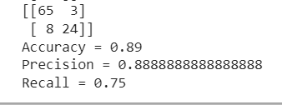

**CONCLUSION:**

1.Illustrated logistic regression algorithm and visualised the output.

2.The accuracy, precision and recall were found to be 0.89,0.89 and 0.75 respectively.